Spring Framework – Introduction

What is Spring?
Spring is a Java framework used to develop web applications, enterprise applications, and backend systems.
A framework provides ready-made tools, features, and a structure that helps developers build applications more easily.
Spring helps developers manage Java objects, connect different classes, work with databases, and develop applications with less repetitive code.
In simple words, Spring makes Java application development easier, more organized, and easier to maintain.

Real-Time Example
Imagine you want to develop a Student Management System using Java.
The system needs to register students, display student details, update student information, and store records in a database.
Spring provides features that help developers organize these tasks into separate components and connect them properly.

Why Do We Need Spring?
When we develop a large application using only Core Java, we need to manage many things ourselves, such as creating objects, connecting classes, handling database operations, and organizing application logic.
As the application grows, maintaining these things can become difficult.
Spring helps solve these problems.
- Object management: Spring can create and manage objects for the application.
- Connecting classes: Spring can provide the objects that other classes need.
- Database operations: Spring supports integration with database technologies.
- Web application development: Spring provides features for handling web requests and responses.
- Application structure: Spring helps developers separate different responsibilities into different components.
- Testing: Spring supports testing application components independently.

Spring Framework Architecture
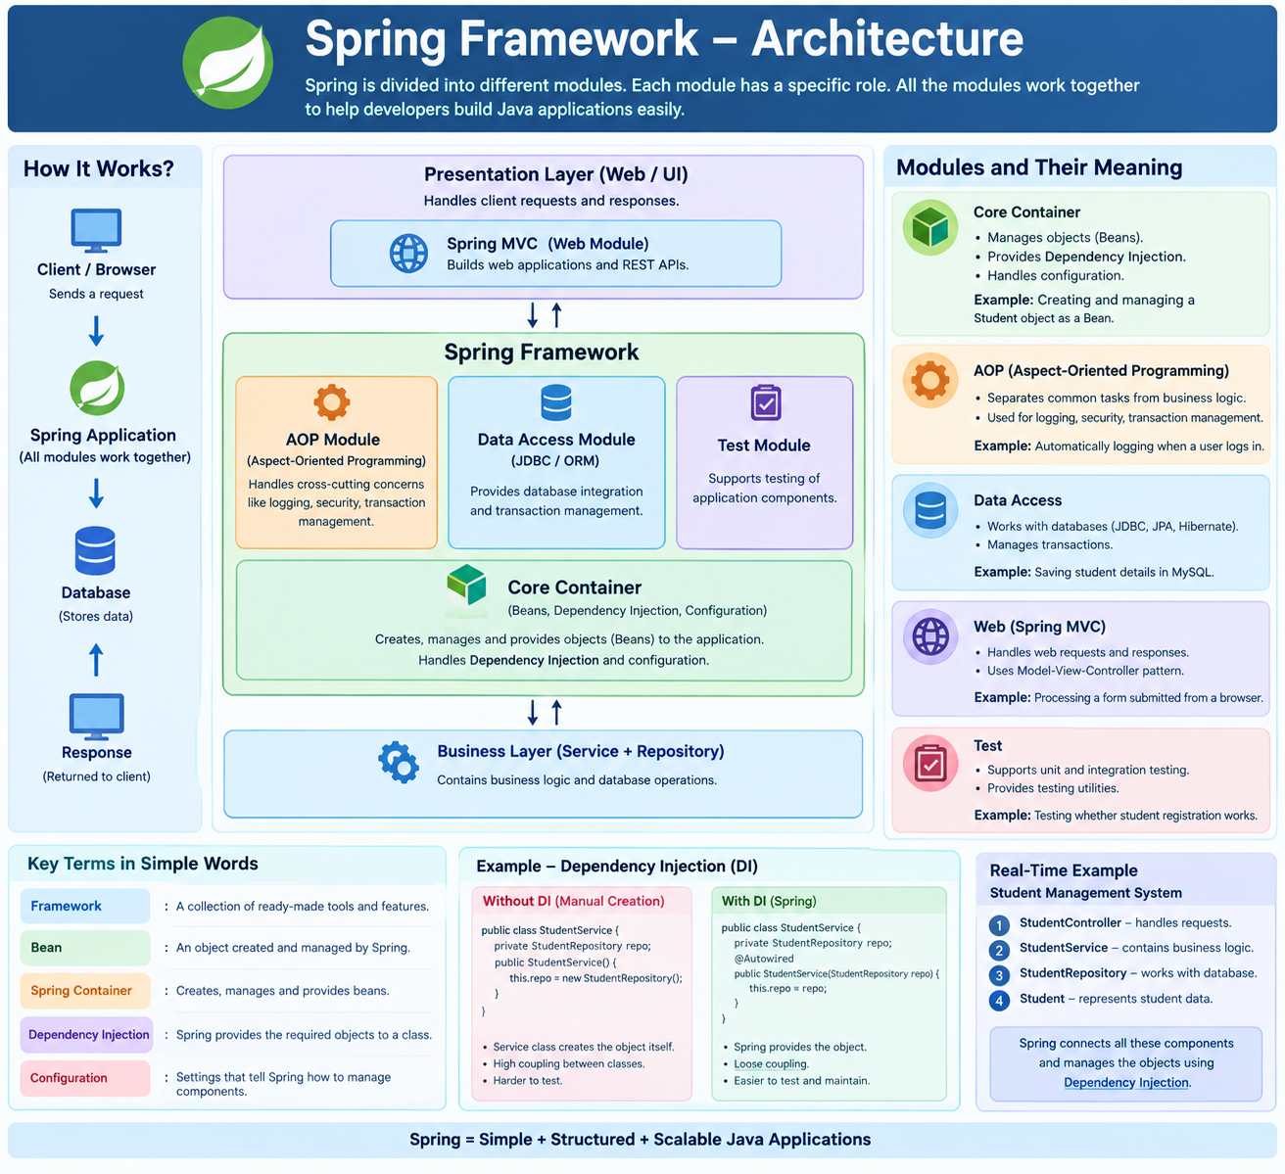

Framework
A framework is a collection of ready-made tools and features that helps developers build applications.
Example: Spring provides features to manage objects and handle web requests, instead of making developers build everything from scratch.

Module
A module is a separate part of the framework that performs a particular job.
Example: The Core Container manages objects, while the Data Access module supports database operations.

Core Container
The Core Container is the basic part of Spring that creates and manages objects.
Example: Spring creates a StudentService object and manages it when the application needs it.

Bean
A Bean is an object created and managed by the Spring Container.
Example: If Spring creates and manages a StudentService object, that object is called a Spring Bean.

Dependency
A dependency is an object or service that a class needs to perform its work.
Example: StudentService needs StudentRepository to save student details. Therefore, StudentRepository is a dependency of StudentService.

Dependency Injection (DI)
Dependency Injection means providing a class with the objects it needs instead of making the class create those objects itself.
Without Spring:
StudentRepository repo = new StudentRepository();
Here, the service creates the repository object itself.
With Spring:
@Service
public class StudentService {

private final StudentRepository repo;

public StudentService(StudentRepository repo) {
this.repo = repo;
}
}
In this example, Spring can provide the StudentRepository Bean through the constructor when creating StudentService, provided that the repository is configured as a Spring Bean.
Why is this useful? The service does not need to create the repository itself. This makes the classes easier to test and maintain.

Configuration
Configuration means the settings or instructions that tell Spring how to set up and manage application components.
Example: Using @Configuration and @Bean to tell Spring how to create a particular object.

Spring Bean Life Cycle
The Spring Bean Life Cycle explains how Spring creates an object, prepares it for use, manages it, and destroys it when required.
Example: In a Student Management System, Spring creates a StudentService object and manages it while the application is running.

Stages of Spring Bean Life Cycle

Bean Definition
Spring first identifies which classes and objects it needs to manage using annotations or configuration.
Example: @Service tells Spring that StudentService is a service component that can be managed as a Bean.
@Service
public class StudentService {
}

Instantiation
Instantiation means creating an object of a class.
Spring creates the Bean object using a suitable constructor.
Example: Spring creates an object of StudentService.

Dependency Injection
Dependency Injection means providing a Bean with the other objects it needs to work.
Example: StudentService needs StudentRepository to save student details. Spring provides the repository object to the service.

Initialization
After creating the Bean and injecting its dependencies, Spring performs initialization callbacks.
Initialization means preparing the object before it is used.
Example: We can use @PostConstruct to run a method that loads required initial data.
@PostConstruct
public void init() {
System.out.println("StudentService is ready");
}
Spring calls this method after dependency injection.

Bean Ready for Use
After initialization, the Bean is ready for the application to use.
Example: A controller calls StudentService to register a student.

Destruction
When the Spring container shuts down, it calls the appropriate destruction callbacks for managed Beans.
Destruction is used to clean up resources when required.
Example: A Bean that manages a resource can close it during shutdown using @PreDestroy.
@PreDestroy
public void cleanup() {
System.out.println("StudentService is shutting down");
}

Simple Flow to Remember
Bean Definition
Instantiation — Create object
Dependency Injection — Provide required objects
Initialization — Prepare the object
Bean Ready for Use
Destruction — Clean up when the container shuts down
Important terms to remember:
- @Service — identifies a service component.
- @Autowired — requests dependency injection.
- @PostConstruct — runs a method during initialization.
- @PreDestroy — runs a method before destruction.

Example :
1) SpringHelloWorld
2) Spring Lifecycle

Dependency Injection (DI) in Spring

What is Dependency Injection?
Dependency Injection (DI) is a feature of Spring in which Spring provides the required object to a class instead of the class creating that object itself.
First, understand two basic terms:
- Dependency: An object that a class needs to perform its work.
- Injection: Providing that required object to the class.
In simple words, Dependency Injection means giving a class the object it needs from outside.

Real-Time Example
Imagine a Student Management System.
The StudentService class needs a StudentRepository object to save student details in the database.
Here, StudentRepository is a dependency of StudentService.
StudentService
Needs a repository to save student data
StudentRepository
Provides database operations
Spring can provide the repository object to the service. This is Dependency Injection.

Without Dependency Injection
The service creates the repository object itself.
public class StudentService {

StudentRepository repo = new StudentRepository();

}
Here, StudentService is directly creating its dependency.
This can make it harder to replace the repository implementation or test the service independently.

With Dependency Injection Using a Constructor
A constructor is a special method that runs when an object is created. It is commonly used to provide the required dependencies.
public class StudentService {

private StudentRepository repo;

public StudentService(StudentRepository repo) {
this.repo = repo;
}
}
Here, StudentService does not create the repository object. It receives the object through its constructor.
Spring can provide the repository Bean when it creates StudentService.
For example, if both classes are registered as Spring Beans:
@Repository
public class StudentRepository {
}
@Service
public class StudentService {

private final StudentRepository repo;

public StudentService(StudentRepository repo) {
this.repo = repo;
}
}
Spring creates and manages these objects and injects the repository into the service, provided component scanning and configuration are set up correctly.

Why Do We Use DI?
- It reduces direct dependency between classes.
- It makes it easier to replace one implementation with another.
- It improves testing.
- It allows Spring to manage object creation and connections.

Types of Dependency Injection
Spring supports different ways to inject dependencies.
Constructor Injection
The dependency is provided through the class constructor.
Example: Passing StudentRepository while creating StudentService.
Recommended for required dependencies.
Setter Injection
The dependency is provided through a setter method after the object is created.
public void setRepo(StudentRepository repo) {
this.repo = repo;
}
Example: Spring creates the service object and then calls setRepo() to provide the repository.
Field Injection
The dependency is injected directly into a class field, commonly using @Autowired.
@Autowired
private StudentRepository repo;
It is simple to demonstrate, but constructor injection is generally preferred for required dependencies.

Example : DI Constructor ,DI Getter Setter,Spring Inheritance

Spring Inner Beans

What is an Inner Bean?
An Inner Bean is a Bean defined inside another Bean's configuration.
It is used when one object is required only by another object and does not need to be shared separately.

Real-Time Example
Suppose a Student class contains an Address object.
The Address object is needed only for that particular Student configuration. We can define the Address Bean inside the Student Bean configuration.

Example
<bean id="student" class="com.demo.Student">
<property name="address">
<bean class="com.demo.Address">
<property name="city" value="Rajkot"/>
</bean>
</property>
</bean>
Here:
- student is the outer Bean.
- address is the Inner Bean.
- The Inner Bean is defined inside the student Bean configuration.
- The Address object is provided to the Student object.

Important Points
- Inner Beans are defined inside another Bean's configuration.
- They are useful when an object is meant to be used only by its containing Bean.
- In traditional XML configuration, Inner Beans do not have their own independent ID or name.
- Inner Beans are mainly associated with Spring XML-based configuration.
Remember: An Inner Bean is a Bean defined inside another Bean's configuration for use by that containing Bean.
Example : Spring Inner Beans

Spring AOP (Aspect-Oriented Programming)
Spring AOP is a feature of the Spring Framework used to handle common tasks separately from the main business logic.
These common tasks include logging, security, transaction management, and performance monitoring.

Why do we need Spring AOP?
Suppose a student management application has Student, Teacher, and Course classes. We want to record when each method starts and ends.
Without AOP, we may need to write logging code inside every method. This makes the code lengthy and difficult to maintain.
With Spring AOP, we can write the logging code once and apply it to multiple methods.

Important Terms in Spring AOP
- Aspect: A class that contains common functionality, such as logging or security.
- Advice: The action performed by an aspect, such as displaying a log message.
- Join Point: A point during program execution where advice can run, typically a method execution in Spring AOP.
- Pointcut: A rule that selects which methods should receive the advice.
- Target Object: The original object whose methods are being monitored or enhanced.
- Proxy: An object created by Spring to apply AOP functionality around method calls.

Types of Advice
- Before Advice: Runs before the target method executes.
- After Advice: Runs after the target method finishes, whether it succeeds or throws an exception.
- After Returning Advice: Runs when the target method completes successfully.
- After Throwing Advice: Runs when the target method throws an exception.
- Around Advice: Runs before and after the target method and can control whether the method executes.

Real-Time Example
Consider a banking application.
When a user transfers money, the application may need to:
- Check security permissions.
- Record the transaction in logs.
- Manage the database transaction.
- Measure how long the transfer takes.
Spring AOP helps keep these common tasks separate from the main money-transfer logic.

Key Point
Spring AOP separates common supporting tasks from business logic, making applications easier to maintain, reuse, and manage.
Example : Spring AOP

Spring Bean Scope

What is Spring Scope?
Spring Bean Scope defines how many instances of a Bean Spring creates and how long those instances are used.
In simple words, Scope tells Spring whether to reuse the same object or create a new object.

Types of Spring Bean Scope
Singleton
Spring creates only one Bean instance per Spring container. The same instance is shared whenever that Bean is requested.
Example: A common application service used by multiple users.
Prototype
Spring creates a new Bean instance each time the Bean is requested from the container.
Example: Creating a separate object whenever a new task object is requested.
Request
Spring creates one Bean instance for each HTTP request. This scope is used in web-aware Spring applications.
Example: Processing a single request to submit a student registration form.
Session
Spring creates one Bean instance for each HTTP session.
Example: Storing user-specific information during a logged-in session.
Application
Spring creates one Bean instance per ServletContext in a web application.
Example: Sharing application-level information across requests in the same web application.
WebSocket
Spring creates one Bean instance for each WebSocket session.
Example: Maintaining session-specific state for a live chat connection.

Important Points
- Singleton is the default Spring Bean scope.
- Prototype creates a new instance each time the container is asked for the Bean.
- Request, Session, Application, and WebSocket scopes require a web-aware Spring environment.
- Scope controls the lifecycle and reuse of Bean instances.
Remember: Singleton means one shared instance per container, while Prototype means a new instance for each container lookup.
Example : SpringScope
Example :Spring Collection and short introduction of collection
Example : Spirng ORM –Explanation
Main Example of Spring MVCORM

